ELEMENTS OF POWER SYSTEMS
EXPERIMENT 5
Codes:
clc
clear all
r=input("enter the ratio X/R: ");
Pr=input("enter the reactive power: ");
Pm=input("enter the meanb power: ");
Pa = input("enter the apparent power: ");
E= input("enter voltage: ");
V= input("enter voltage: ");
Z= V^2/Pa
R=Z/sqrt(r^2+1)
X=r*R
a=(2*R*Pm-E^2+V^2)*V^2 +R^2*Pm^2+X^2*Pm^2;
b=2*V^2*X;
c=(X^2 + R^2);
p=[c b a];
Q=max(roots(p))
Qadd=Q-Pr

Output:
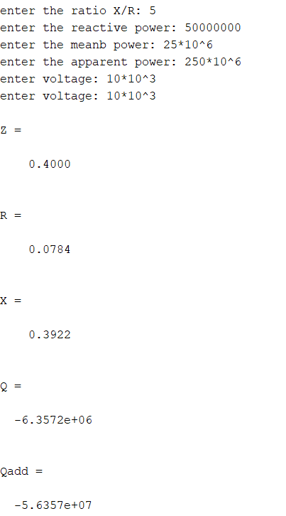

MATLAB Circuit Diagram:

Without compensator (Voltage and current graphs):
With compensator (voltage and current graphs):

